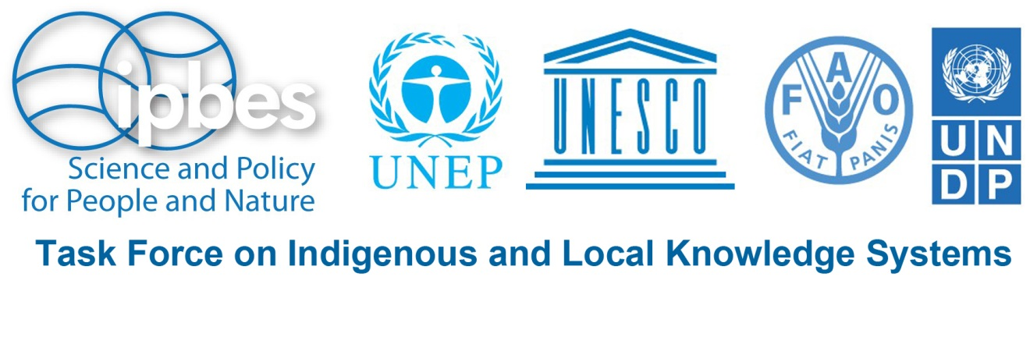
Call for Submissions

Indigenous and Local Knowledge for
Regional Assessments of Biodiversity and Ecosystem Services
The assessments focus on one or more of the following themes:
- land degradation & restoration
- sustainable use & conservation
- invasive alien species & their control

Deadlines for Submission:
- 15 June 2015 for the Africa region
- 29 June 2015 for the Europe & Central Asia region
- 15 July 2015 for the Americas and Asia & the Pacific regions

[link to website location here]
La version en français sera disponible à partir du 14 mai en suivant le lien : XXX
La versión en español estará disponible a partir del 22 mai aquí: XXX

The Intergovernmental Platform on Biodiversity and Ecosystem Services (IPBES) is conducting assessments of biodiversity and ecosystem services. These assessments are to be based on, in addition to scientific knowledge, the knowledge, practices, observations and understandings of indigenous peoples and local communities.
An important aspect of the assessment is to deal with interrelationships between biological diversity and society, including nature’s benefits to people, as well as human well-being. They focus on changes that affect food, water, energy, livelihoods and health. They also consider the importance of biodiversity for social relationships, spirituality and cultural identity, and address issues of equity, including inter- and intra-generational equity.

If your community has relevant indigenous and local knowledge (ILK) to contribute, or if you know of projects or publications on ILK and biodiversity, its benefits for and relationships with local communities and indigenous peoples, then please submit your information on the link below!

The OVERALL AIM is to assess the current state of our natural environment, including its biological diversity and ecosystem functions and services, while also identifying important changes and trends.

Some KEY QUESTIONS are:
- How does biodiversity contribute to the livelihoods, food security, and quality of life of indigenous peoples and local communities?
- How do indigenous peoples and local communities conserve, manage and create biological diversity?
- What changes in the natural environment are being observed by indigenous peoples and local communities and what is driving those changes?
- What impacts do existing policies and interventions have on biodiversity and ecosystem services and as a result on the well-being of indigenous peoples and local communities?

Regional assessments follow a basic format and address the following four regions:
- Africa
- the Americas
- Asia & the Pacific
- Europe & Central Asia
Note that in 2015, the task force will focus on ILK in two regional assessments (Africa and Europe & Central Asia). In 2016, the work programme will extend to ILK in the Americas and Asia & the Pacific.

The assessments address the following three themes:
- land degradation & restoration:
Land degradation is defined as a long-term decline in biodiversity or ecosystem function or loss of ecosystem services from which land cannot recover unaided. It is a major environmental problem and all continents with permanent human settlement are affected by it in different forms and on various scales.
- sustainable use & conservation
The objective of the proposed thematic assessment is to assess the ecological, economic, social and cultural importance, conservation status, drivers of change, and related livelihoods and values for local communities and indigenous people, of mainly harvested and traded wild species in order to identify and promote best practices and tools, including both modern technologies and indigenous and local knowledge and methods, for sustainable management and harvesting.
- invasive alien species and their control
Invasive alien species include a vast and rapidly increasing number of non-native terrestrial, freshwater and marine vertebrates, invertebrates, plants and disease organisms. They constitute one of the most serious, rapidly growing and hard-to-address threats to biodiversity, ecosystem services and food, health and livelihood security.

WHO CAN PARTICIPATE?
Knowledge holders who are indigenous peoples or from local communities, ILK researchers/scientists or other persons knowledgeable about indigenous peoples and local communities and their relationship with biodiversity and ecosystems.

HOW CAN YOU CONTRIBUTE?
By submitting information on:
- Past or on-going projects informed by indigenous and local knowledge (ILK) about land degradation and restoration, sustainable use and conservation, and/or invasive alien species;
- Scientific or grey literature on ILK about land degradation and restoration, sustainable use and conservation, and/or invasive alien species;
- ILK holders, researchers or other knowledgeable individuals who are or have been involved in projects on ILK about land degradation and restoration, sustainable use and conservation, and/or invasive alien species.

Invitation to participate in an International Workshop:
A limited number of contributors (ILK holders and experts) will be invited to a Dialogue Workshop for the Africa region (to be tentatively held 27-31 July 2015) and for the Europe & Central Asia region (tentatively 26-30 August 2015). Travel grants will be made available for participants from developing countries. The workshops will bring ILK holders and experts together to enrich the regional and thematic assessments on biodiversity and ecosystem services. A further goal will be to engage ILK holders in IPBES processes and demonstrate the potential benefits and opportunities for their communities.
Dialogue Workshops for the Americas and Asia & Pacific regions are planned for early 2016, pending approval of the IPBES Plenary.
Selected ILK holders and experts may also be invited to participate in:
- a preparatory meeting before the ILK Dialogue Workshop: to provide background information on IPBES assessments and to initiate the gathering of relevant ILK from local knowledge holders, communities and networks, as well as to identify priority issues and concerns;
- a follow-up meeting after the ILK Dialogue workshop: to consult with local knowledge holders, communities and networks on issues and questions raised in the assessment process and to provide feedback to local partners and communities.

Please note that English will be the primary working language of meetings. French-English interpretation will be provided in meetings in Africa.
All submissions will be reviewed by the IPBES Task Force on Indigenous and Local Knowledge Systems. Please indicate on your submission form that the information you provide may be used and eventually published in the framework of the IPBES assessment as a relevant case study. Please also indicate whether you would agree that your name be included in a list of ILK experts.
A fundamental principle of IPBES is full respect for indigenous and local knowledge. Therefore, submissions should not include secret, sacred or otherwise confidential knowledge without the free, prior and informed consent of the holders of that knowledge.
Deadline for submissions:
- 15 June 2015 for the Africa region
- 29 June 2015 for the Europe & Central Asia region
- 15 July 2015 for the Americas and Asia & the Pacific regions

To make your submission please go here.
For those who have problems filling the online form, you may download the form here.
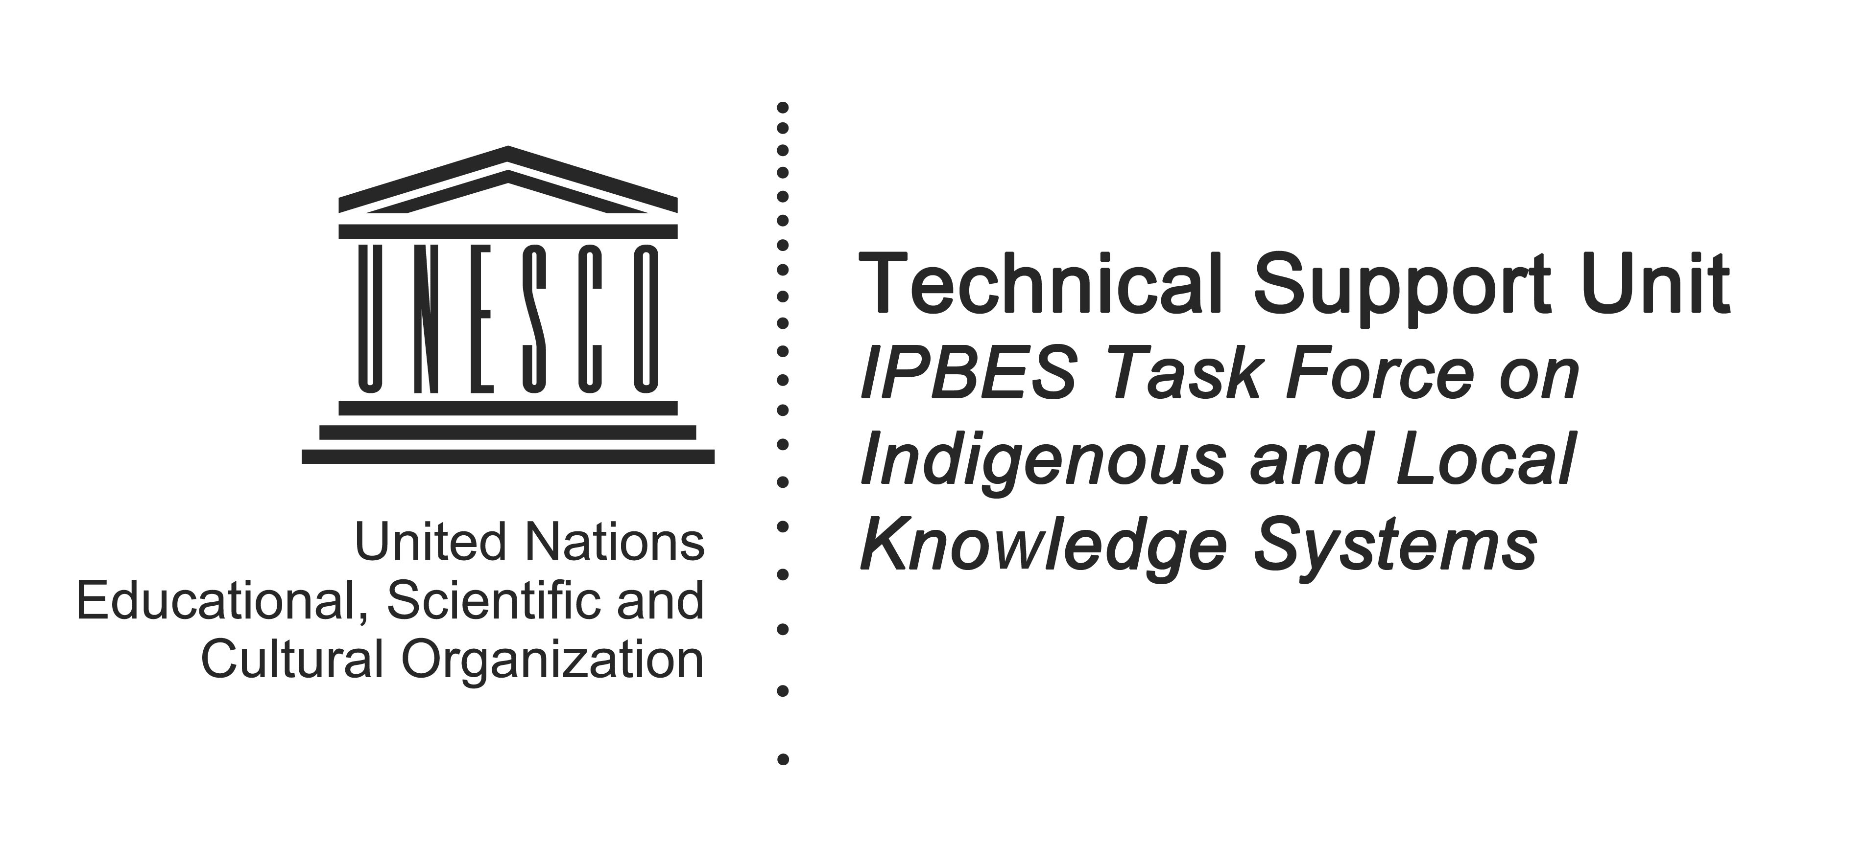
For additional information, please contact the Technical Support Unit for the IPBES Task Force at links@unesco.org
This is the second of a series of periodic calls for submission by the IPBES Task Force on Indigenous and Local Knowledge Systems.

