ANNEX to the Application form for the WHRTI /2016- 2017/: Workshop on Women’s Economic, Social and Cultural Rights
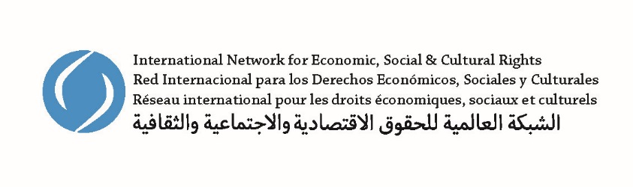

In 2016, the Women’s Human Rights Training Institute will partner with the International Network for Economic, Social and Cultural Rights (ESCR-Net) to provide an additional two-day workshop immediately following the September 2016 WHRTI session, on 3 and 4 October 2016.
Co-convener: The International Network for Economic, Social and Cultural Rights (ESCR-Net) unites over 270 NGOs, grassroots groups, and advocates across 70 countries, facilitating strategic exchange, building solidarity, and coordinating collective advocacy to secure social and economic justice through human rights. ESCR-Net members define common strategies and advance joint action foremost through international working groups, including the Working Group on Women and ESCR which is made up of over 40 members – NGOs, social movements, and individual advocates – working across regions to advance women’s ESC rights and substantive equality. Through engagement with UN bodies, capacity building, and advocacy at multiple levels, the Working Group works collectively to ensure women’s experiences and analyses are at the center of domestic and international policy-making and legal developments.
Workshop focus: This workshop will focus on the advancement of women’s economic, social and cultural rights through engagement with UN mechanisms, particularly the Committee on the Elimination of Discrimination against Women and the Committee on Economic, Social and Cultural Rights. Over the two days, participants will exchange experiences and explore:
- how to engage strategically with the committees through the complaints procedures connected with, respectively, the Convention on the Elimination of All Forms of Discrimination against Women (CEDAW) and the International Covenant on Economic, Social and Cultural Rights (ICESCR);
- how to develop complementary strategies, for example, parallel/shadow reporting; and
- landmark jurisprudence that can be applied in regional/national contexts to advance substantive equality and women’s economic, social and cultural rights.
To apply: Please describe, in 300 words or less, why you are interested in attending this workshop, which economic, social and cultural rights issues are of particular relevance for women in your country, and any work you are currently doing in this area (if not already covered in your answers in the application form above).

